Reg. No. CODE: COREMATH

PH. D COURSEWORK EXAMINATION, MAY 2023
DEPARTMENT: MATHEMATICS
CORE PAPER

Time: 03 hours Maximum Marks: 50
Name: Ms. Swapna Sangeetha and Ms. Chaitali

Instructions:
- Question No.1 is compulsory and answer any 4 from questions 2 to 7
- Statistical tables can be provided
- Missing values may be considered suitably

1 | - Describe Mass Spring System in detail.  - Explain Different methods of sampling with suitable examples. | 2x5=10
2a | The average volume of traffic for a few intersections per red light is given. Find all possible values for $x_{1} ,x_{2}$and $x_{3}$ . What is the minimum volume of traffic from C to A.  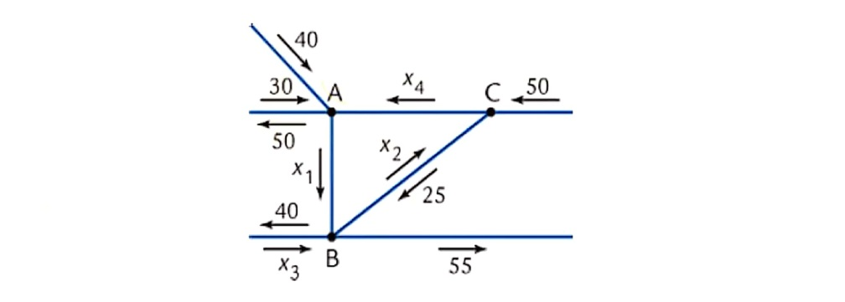 | 5
2b | a. Find the general traffic pattern in the freeway network shown in the figure. (Flow rates are in cars/minute.)  b. Describe the general traffic pattern when the road whose flow is x₄ is closed.  c. When x₄ = 0, what is the minimum value of x₁?  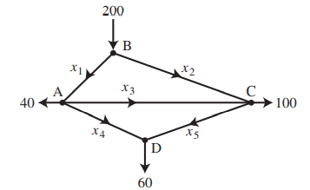 | 5
3a | Assume a tank in the shape of an inverted cone, with height 12 ft and base radius 4 ft. The tank is full to start with, and water is pumped over the upper edge of the tank until the height of the water remaining in the tank is 4 ft. How much work is required to pump out that amount of water? | 5
3b | Use the natural cubic spline to determine y at x = 1.5. Data points are as follows: (2, 1), (1, 0), (5, 0), (3, 0), (4,1). | 5
4a | Find the Consumer Price Index from the following data. Using  - Aggregative Expenditure Method and  - Family Budget Method  Is there any difference between the two results?  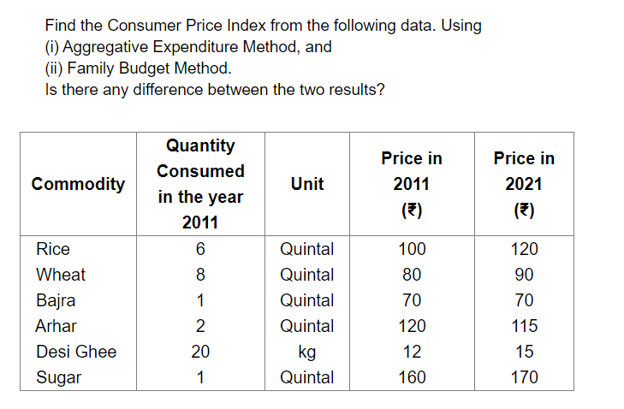 | 5
4b | Given below are the data relating to the sales of a product in a district. Fit a straight line trend by method of least squares and tabulate the trend values and estimate the trend value of 2005.  Year 1995 1996 1997 1998 1999 2000 2001 2002  Sales 6.7 5.3 4.3 6.1 5.6 7.9 5.8 6.1 | 5
5a | The heights of adult females are normally distributed with mean 160 cm and standard deviation 8 cm.  a) Find the probability that a randomly selected adult female has a height greater than 170 cm.  Any adult female whose height is greater than 170 cm is defined as tall.  An adult female is chosen at random. Given that she is tall,  b) find the probability that she has a height greater than 180 cm.  Half of tall adult females have a height greater than $h$ cm.  c) Find the value of $h.$  Given$∅\left(1.25\right)=0.3944$ $∅\left(2.5\right)=0.4938$ $∅\left(1.62\right)=0.4474$ | 5
5b | The joint distribution of two varaibles X and Y is as follows  X/Y -4 2 7  1 1/8 1/4 1/8  5 1/4 1/8 1/8  Compute the following  - E(X) and E(Y)  - E(XY)  - $σ_{x}$ and $σ_{y}$  - $COV\left(X,Y\right)$  - $ρ(X,Y)$ | 5
6a | A population consists of five numbers 2, 3, 6, 8 and 11. Consider all possible samples of size two which can be drawn with replacement from this population. Find  (a) The mean of the population.  (b) The standard deviation of the population.  (c) The mean of the sampling distribution of means and  (d) The standard deviation of the sampling distribution of means (i.e., the standard error of means) | 5
6b | Explain Statistical Estimation and the type of Estimations in detail by giving suitable examples.
7a | Find the current at any time t>0, in a circuit having in series a constant electromotive force 40 v, a resistor 10Ω, and an inductor 0.2 H given that initial current is zero. Find the current when E(t)=150 cos200 t. | 5
7b | A bacterial population B is known to have a rate of growth $α$ to B itself. If between noon and 2pm the population triples, at what time no control being exerted, should B become 100 times what it was at noon? | 5

********

